STEPPER MOTOR USING AT89C51 USING PROTEUS

AIM:
To write an assembly language program for Stepper Motor Using AT89C51 using Keil and
Proteus.

SOFTWARE REQUIRED:
Proteus 8 software.

PROGRAM:

ORG 0000H
UP: MOV P2.#09H
ACALL DELAY
MOV P2.#0CH
ACALL DELAY
MOV P2.#06H
ACALL DELAY
MOV P2.#03H
ACALL DELAY
SJMP UP
DELAY:MOV R4.#18
HI:MOV R3.#255
H2:DJNZ R3.H2
DJNZ R4.H1
END
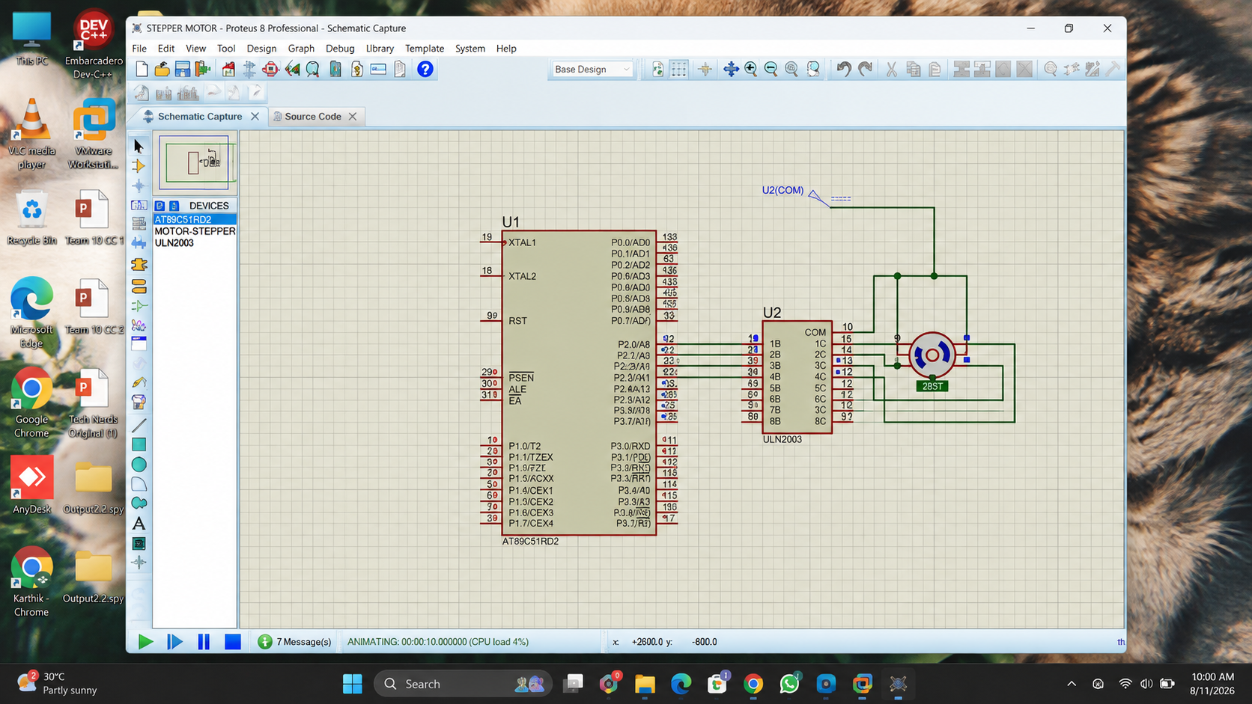

RESULT:
Thus the program has been successfully verified and executed.

